**HW8 Double Sideband Mod**

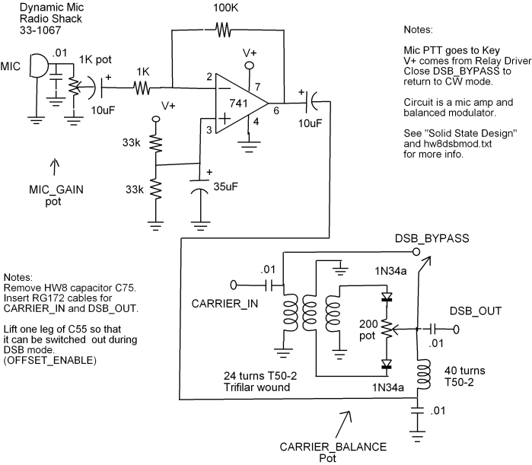

**The Story**

25 years ago I worked in bush during summers while going to college I used to be net control for "The Bush Net" on 7250 while there. I took out my HeathKit HW101 and power supply which weighed a ton. and was difficult to pack into the small planes which are taxis for the folks that live away from town. I built an HW8 for fun and thought it might be easier to pack to bush.

I noticed that with the DC receiver I could tune in either sideband, I also noticed that it was more difficult to tune in cw as there were two places on the dial where a signal appeared but only one was real.

I had been reading a copy of "Solid State Design for the Radio Amateur" at the time. I read comments about DSB rigs and balanced modulators and had an epiphany.

I knew at that point that inserting a balanced modulator in the transmit oscillator chain would work to put the HW8 on sideband.

I had previously built an audio speech clipping processor using a 741 and some back to back silicon diodes so knew that a 741 would have enough gain to drive the balanced modulator diodes.

There were some schematics in Solid State Design for a DSB 50Mhz rig and a number of simple balanced modulator circuits.

I figured that I could just drop a balanced modulator between Q5 and Q8. I cut a trace on the circuit board and ran some RG174 in and out of the balanced modulator to the circuit board on either side of the trace cut.

I suppose it was a lucky guess but it worked.

I stole a couple of the toroids from the 15 meter band switch and rewound them as a balanced modulator.

The first time I built this mod I used silicon diodes and didn't have a carrier balance pot and worked great on the first try. I guess it pays to be Irish.

Carrier suppression seemed pretty good so I listened to my DSB transmit on my HW101 on either sideband and set the audio level to where it sounded ok and called it done.

At the time I had a 40 meter sloper array around my tower which, incidentally, works very well. The best contact I made on that band ever was with my HW8 DSB to New Zeland from Alaska. 7000miles/2 watts = 3500 miles per watt That is pretty good considering the HW8 puts out about 2 watts on CW so each sideband is putting out only 1 watt.

Subtract an S-unit or two for worse signal to noise of sideband vs CW and that was a pretty cool contact for 40 meters. Hmmm... What would that be if it was CW? 2 S-units = 12 db = 4x power. 7000 miles * 4 = 28000 miles per watt CW equivalent But I digress...

Anyway, I took the HW8 out to the bush with me the next summer and checked into Anchorage from the Yukon River Delta all summer. I was using a trap vertical stuck in the tundra with 4 radials. The amazing thing that I found was that the net controls could copy me BETTER on sideband than on CW even considering the power drop and increase in signal to noise. That was 25 years ago when the net controls could copy CW pretty well... They seemed to be willing to listen harder to voice than to CW.

I sold that HW8 somewhere along the line. Don't recall where it went. I believe I had ripped the dsb mod out of the HW8 before I sold it.

I never saw a similar mod anywhere else and often thought it would be cool to re-create it and publish the results sometime. I got another HW8 about 15 years ago and attemped but failed to recreate the circuit. I tried again last week and was successful. This time I didn't cut the circuit board trace but instead just removed C75 and ran RG174 in and out of the holes where C75 used to be.

I chose to use germanium diodes instead of silicon this time for the lower cut-in voltage (.2 vs .7 volts).

I tried a couple of simple balanced modulator circuits from Solid State Design but kept having a problem where I could not get good carrier balance on 80 and 40 meters. I got good carrier balance on 20 and 15. I tore the circuit apart and rebuilt a different type circuit and still had the same problem. I doubled the number of turns on the trifilar balanced transformer and same problem.

Finally I rewound the audio choke from 24 turns to 40 turns and then the balanced modulator started working well with good carrier balance on 80 40 20 and 15 meters.

I breadboarded up a speech amp using Heathkig design experimenter and ran the audio from the speech amp using clipleads into the balanced modulator. I hooked a scope to my antenna output and adjusted the drive to look like a clean SSB signal without too much flat topping.

[PIC1 OF DEVELOPMENT STAGE] 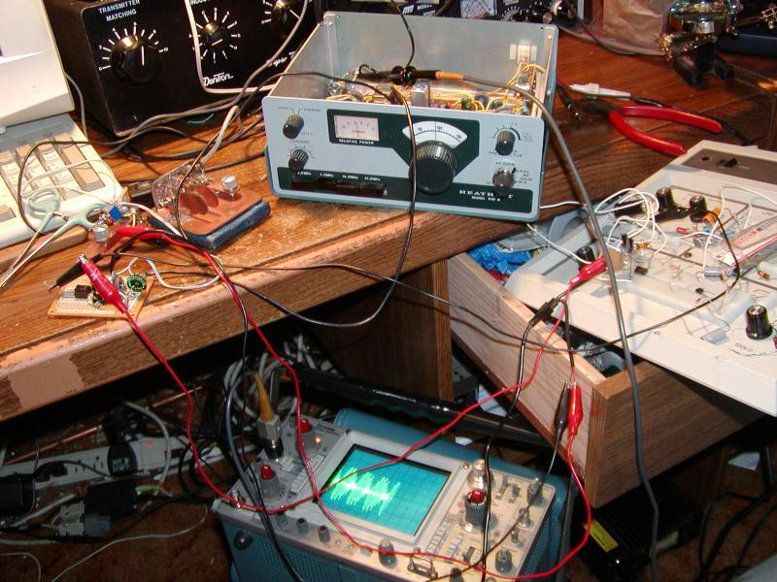

I fired it up on the Bush Net at 7093 and gave a call:

"This is KL7R QRP 1 watt double sideband"

A fellow in Fairbanks (about 650 miles away) came back to me:

"You are S7 here but you are way off frequency"

NL7F also came back and said

"You sound clean on both sidebands and are about 2kHz off frequency"

So I downloaded a copy of the manual and schematics from: ftp://bama.sbc.edu/downloads/heath/hw-8/

The circuit description said that C55 was switched in and out of circuit on transmit and provides a transmitter offset. I thought maybe I can just remove C55 and then my transmitter and receiver would no longer be offset. I lifted one leg of C55 and waited for the Bush Net the next day.

I checked in and my transmit frequency was exactly the same as my receive frequency. NL7F said: "You sound clean on both sidebands and are zero beat with the net."

Time to make it production...

I tore apart my manhattan version of the balanced modulator and put it on a piece of Radio Shack board. I tore apart the breadboarded speech amp and also put it on the Radio Shack board. I ran wires to +12v and ground, to the mic and ptt, to the key jack, to a DPDT switch for power and to short past the modulator in cw mode.

I checked into the 40 meter net the next day. Getting routine.

I called a guy in Seattle on 20 (about 900 miles away). He gave me a 59+10db. He asked what kind of antenna I was running on my 1 watt DSB rig. I said a loop skywire for 80. He said he was running a "4 over 4 over 4 over 4". I said "Ill take it".

So now Im thinking I would like to be able to switch back in C55 while in CW mode but I only have the one DPDT switch and I need to switch the power off to the speech amp during cw mode.

I decided to use the relay driver output (which keys on 12 volts during transmit and is off during receive) to power the 741. I ran wires so that C55 is in circuit when the switch is in CW mode and out of circuit when in DSB mode. The switch also bypasses the balanced modulator when in CW mode.

Some double sided foam mounting tape mount the mod to the side of HW8 and we are done.

[DETAIL PIC OF CIRCUIT BOARD MODS] 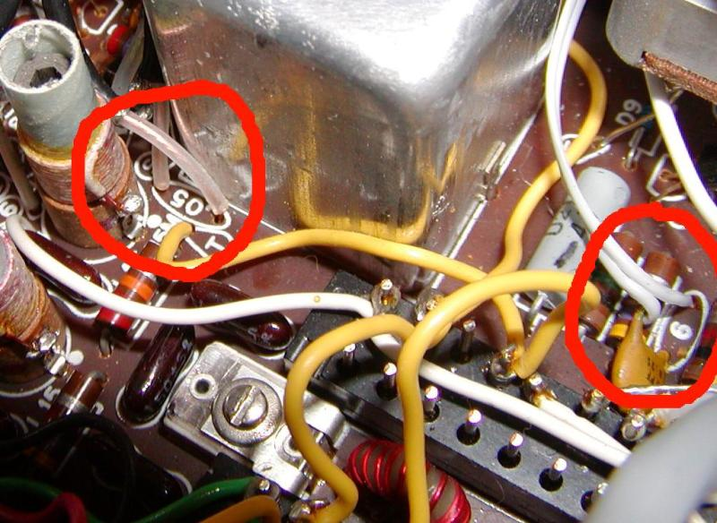

Here are detailed instructions for the mod:

http://kl7r.ham-radio.ch/hw8/hw8dsbmod.txt

HW8 DSB mod

STOP!!

Before you do anything put a 1 amp fuse in your power line.

I blew 5 fuses developing this circuit... I was REALLY happy

to have fuses go instead of components.

Remove top and bottom covers.

1. Remove c75 (.05 uF).

Located between the emitter of Q6 and the base of Q8.

Physically located between the group of 4 uncanned tuning coils

and the large canned tuning coil.

2. Insert two lengths of RG172 into the holes where c75 used to be.

Find a place to ground the shields. I soldered onto the nearby

RG172 shield. The cable from the emitter of Q3 will be CARRIER_IN

the cable going to the base of Q8 will be DSB_OUT. Hole to rear

of HW8 is CARRIER_IN. Hole to front is DSB_OUT. Refer to HW8

schematic and circuit board.

3. Lift up one leg of c55. (6 pf)

Located near face plate to the left of the VFO capacitor.

This cap is to offset from zero beat in CW mode. We dont want to

be offset when doing DSB.

4. Solder a 2 conductor length of ribbon cable to the lifted end of c55

and to the hole that it came out of.

This pair of wires called OFFSET_ENABLE will be used to switch c55

in circuit for CW where you need it and out of circuit for DSB where

you dont.

That is all the soldering you need to do on the main circuit board so you

can put the bottom cover back on.

5. Create the hw9dsbmod circuit located at http://kl7r.ham-radio.ch/hw8/

6. Attach the CARRIER_IN cable to CARRIER_IN.

7. Attach the DSB_OUT cable to DSB_OUT.

8. Attach the ground wire to the antenna ground lug.

9. Attach the V+ wire to wire connection point "J"

(may need to cut a little bit of shielding back in order to solder

to the wire inserted in point "J".

Point "J" is connected to the collector of relay driver Q13 and

supplies 12 volts during key down.

10. Drill two holes in back panel and mount a DPDT switch and a 1/8 ""

stereo phone jack.

11. Attach two lengths of two conductor ribbon conductor to the center and

upper connections of the DPDT switch.

12. Attach one pair of the ribbon cables in step 11 to DSB_BYPASS.

13. Attach the other pair of ribbon cables in step 11 to OFFSET_ENABLE.

14. Connect a length of RG174 to the 1/8 jack.

(MIC to jack tip. mic sheld to ground)

NOTE: Put a .001 cap from MIC to shield on the jack to

shunt any RF on the mic cable to ground

15. Connect a length of 2 conductor ribbon cable to the 1/8 jack.

(PTT to jack ring. remaining connector to jack ground)

16. Attach MIC and mic shield to the dsb circuit

17. Attach PTT and its ground to the key jack on the back panel.

All done with connections.

Adjustment.

1. Switch the switch to CW.

2. Adjust loading for max out into dummy load. Note meter reading.

3. Switch the switch to DSB.

4. Key the Mic PTT and adjust CARRIER_NULL pot for minimum.

5. Adjust MIC_GAIN pot on voice peaksfor about 50% of max CW reading.

All done with adjustment.

Notes:

I used #28 wire (green Radio Shack hookup wire) for the toroids.

I know that 24 turns was too few on the output choke so went to

40 turns on the output choke. It worked on 20 and 15 but not on

40 and 80 with 24 turns so had to go to 40 turns.

I had 12 turns on the transformer and that seemed to work but

went to 24 turns which worked well also so I never went back.

I spent some time matching the diodes. Silicon diodes should work

but I used germanium like 1N34a for lower cut in voltage. I selected

a pair with similar forward and reverse resistances and cut in voltages.

If you get a really good pair, you might be able to remove the balance pot.

When I built this 25 years ago I used silicon diodes and no balance pot.

I also cut the circuit board then instead of removing C75.

An interesting note: If you switch to DSB and then zero beat a CW station

then switch to cw you will be right on him with the correct offset.

Likewise, sometimes a CW station will come back to you zero beat -

switch to DSB mode on receive to get a proper offset.

All done

[MOD MOUNTED ON SIDE OF HW8] 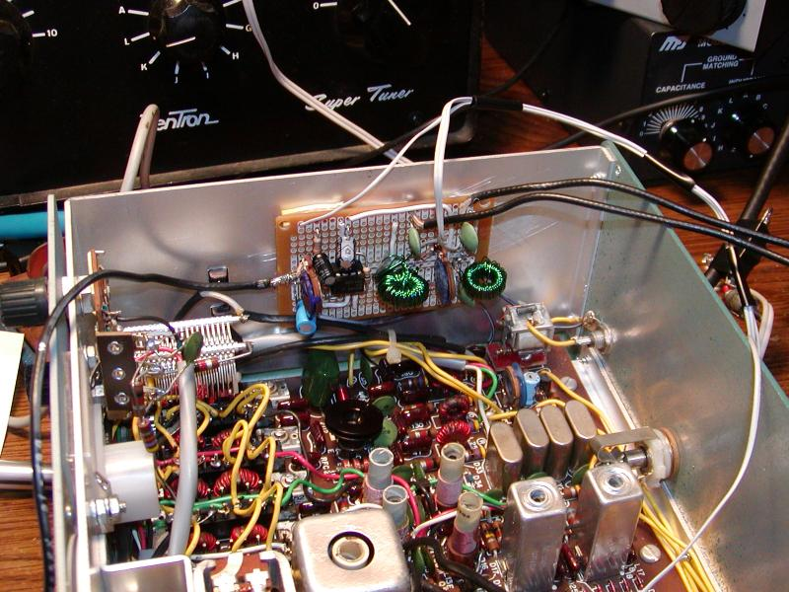

[DETAIL OF CIRCUIT BOARD] 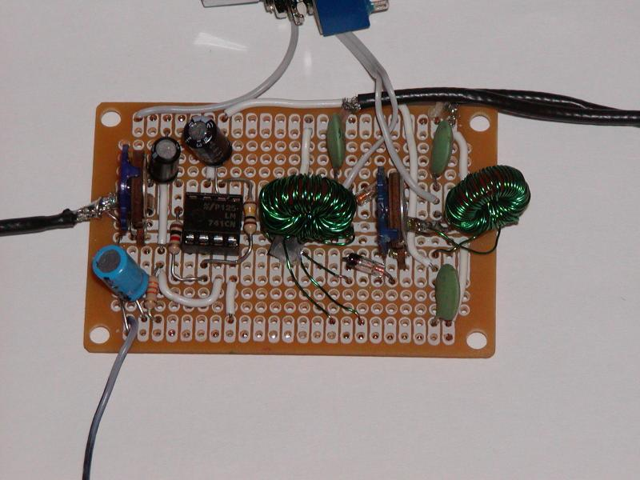

Future plans:

Try it on PSK. (Actually I did try it on PSK. Found out that I need

a bypass cap across the mic and mic shield to block RF from getting

into the speech amp.)

Find an S-Meter mod.

Find a higher power mod.

Tuned Exaust - Racing Stripe.